Q1. Write difference between SAAS, PAAS, IAAS.

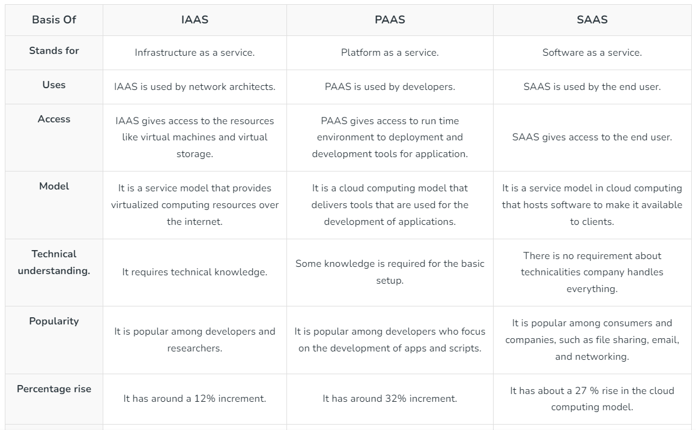

Q2. Explain with diagram architecture of cloud(public) any provider.

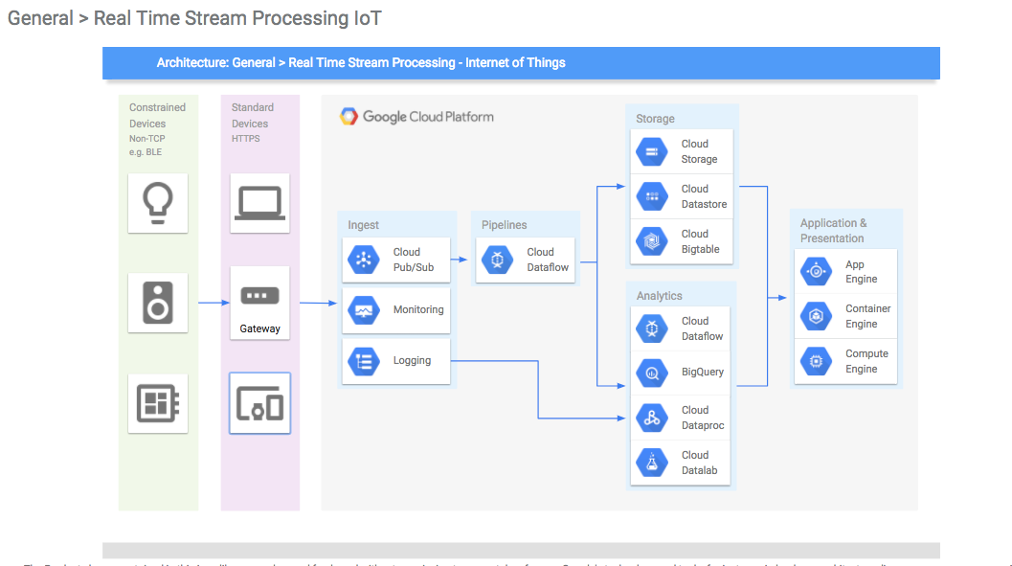

Global Network Infrastructure: Google Cloud's foundation is a global network infrastructure that includes data centers and points of presence (PoPs) distributed worldwide.This network is designed for high performance, low latency, and reliability.

Regions and Zones: Google Cloud is organized into regions, each containing multiple zones.A region is a specific geographical location where users can deploy resources.Zones are isolated data centers within a region, providing redundancy and fault tolerance.

Compute Engine: Google Compute Engine (GCE) is the infrastructure-as-a-service (IaaS) offering, allowing users to run virtual machines (VMs) on Google's infrastructure.VMs can be customized with different configurations based on the user's requirements.

App Engine: Google App Engine is a platform-as-a-service (PaaS) offering that enables developers to build and deploy applications without managing the underlying infrastructure.It supports automatic scaling based on application demand.

Kubernetes Engine: Google Kubernetes Engine (GKE) is a managed Kubernetes service that simplifies the deployment, management, and scaling of containerized applications.

Storage Services: Google Cloud provides various storage options, including Cloud Storage for object storage, Cloud SQL for relational databases, and Cloud Bigtable for NoSQL databases.

BigQuery: BigQuery is a fully-managed, serverless data warehouse for running fast and SQL-like queries on large datasets. It's part of Google Cloud's big data and analytics services.

Identity and Access Management (IAM): IAM is a crucial component for managing access control and permissions within Google Cloud. It allows users to define roles and assign them to individuals or groups.

Networking Services: Google Cloud offers a range of networking services, including Virtual Private Cloud (VPC), Load Balancing, and Cloud CDN, to ensure secure and efficient communication between resources.

AI and Machine Learning Services: Google Cloud provides a suite of AI and machine learning services, such as TensorFlow, AutoML, and AI Platform, to enable developers to integrate intelligent features into their applications.

Security and Compliance: Google Cloud emphasizes security with features like encryption at rest and in transit, Identity-Aware Proxy (IAP), and compliance certifications to meet industry standards.

Monitoring and Logging: Stackdriver (now part of Google Cloud Operations Suite) offers monitoring, logging, and diagnostics tools to help users gain insights into the performance and health of their applications and infrastructure.

Q3. Study about five services from AWS, GCP, Azure and Heroku.

Amazon Web Services (AWS):

Amazon EC2 (Elastic Compute Cloud):

Use Cases: Hosting applications, web servers, databases, and running custom software.

Amazon S3 (Simple Storage Service):

Use Cases: Data backup, static website hosting, content distribution, and data archiving.

Amazon RDS (Relational Database Service):

Use Cases: Hosting and managing relational databases without the overhead of administrative tasks.

AWS Lambda:

Use Cases: Event-driven computing, microservices, and running code without managing infrastructure.

Amazon CloudWatch:

Use Cases: Monitoring, alerting, and troubleshooting of AWS resources and applications.

Google Cloud Platform (GCP):

Compute Engine:

Use Cases: General-purpose computing, hosting applications, and running custom workloads.

Cloud Storage:

Use Cases: Data storage, backup and recovery, content distribution, and serving static assets.

Cloud SQL:

Use Cases: Managed relational databases without the operational overhead.

Cloud Functions:

Use Cases: Event-driven computing, microservices, and serverless architecture.

Stackdriver (now part of Cloud Operations Suite):

Use Cases: Monitoring, logging, and troubleshooting GCP resources and applications.

Microsoft Azure:

Azure Virtual Machines:

Use Cases: General-purpose computing, hosting applications, and running custom workloads.

Azure Blob Storage:

Use Cases: Data storage, backup and recovery, content distribution, and serving static assets.

Azure SQL Database:

Use Cases: Managed relational databases without the operational overhead.

Azure Functions:

Use Cases: Event-driven computing, microservices, and serverless architecture.

Azure Monitor:

Use Cases: Monitoring, alerting, and diagnostics for Azure resources and applications.

Heroku:

Heroku Dynos:

Use Cases: Rapid application deployment, scaling web applications, and development without infrastructure management.

Heroku Postgres:

Use Cases: Managed relational databases without administrative overhead.

Heroku Redis:

Use Cases: Caching, session storage, and real-time analytics.

Heroku App Metrics:

Use Cases: Application performance monitoring and troubleshooting.

Heroku Connect:

Use Cases: Integrating Salesforce data with Heroku applications.

Q4. Write the difference between database services of AWS , GCP, Azure, Heroku.

Amazon Web Services (AWS):

Amazon RDS (Relational Database Service): Fully managed relational database service that supports multiple database engines such as MySQL, PostgreSQL, Oracle, SQL Server, and MariaDB.

Amazon DynamoDB: Fully managed NoSQL database service that provides fast and predictable performance with seamless scalability.

Amazon Redshift: Fully managed data warehousing service that allows for the analysis of large datasets using standard SQL.

Google Cloud Platform (GCP):

Cloud SQL: Fully managed relational database service that supports MySQL, PostgreSQL, and SQL Server.

Cloud Spanner: Globally distributed, horizontally scalable relational database service offering strong consistency and high availability.

Firestore: Fully managed NoSQL document database for building web, mobile, and server applications.

Microsoft Azure:

Azure SQL Database: Fully managed relational database service based on SQL Server engine, providing high availability, security, and performance.

Azure Cosmos DB: Globally distributed, multi-model database service offering support for NoSQL data and multiple consistency models.

Azure Database for PostgreSQL/MySQL/MariaDB: Fully managed database services for PostgreSQL, MySQL, and MariaDB, providing high availability and scalability.

Heroku:

Heroku Postgres: Fully managed relational database service based on PostgreSQL, offering high availability, data protection, and automated health checks.

Heroku Redis: Fully managed in-memory data store service based on Redis, providing caching, queuing, and transient storage.

Heroku Connect: Data synchronization service that connects Heroku applications with Salesforce, enabling seamless data flow between the two platforms.

Advanced Assignments(optional)

Q1. Find services for big data on AWS , GCP Azure,Heroku.

Q2. Compare services for big data on AWS , GCP Azure,Heroku.

Q3. Find services for Machine learning on AWS , GCP Azure,Heroku.

Q4. Compare services for Machine learning on AWS , GCP Azure,Heroku.